**Discover Samsung Sale**

**990 PRO w/ Heatsink PCIe® 4.0 NVMe™ SSD 2TB**

**MZ-V9P2T0 /MZ-V9P2T0GW**

Share your product experience

* • Got a need for speed? Gen4 steps up to the arena with more than 55% improvement in random performance compared to 980 PRO.  
  • The speed you need for any occasion. With read and write speeds up to 7450/6900 MB/s³ you’ll reach near max performance of PCIe® 4.0³ powering through for any use.  
  • Give yourself some space with storage capacities up to 2TB. Sync all your saves and reign supreme in gaming, video editing, data analysis and more.  
  • Power through all your go-to games and avoid the sudden performance drops. The ultra-slim Integrated Heatsink dissipates heat from your device for uninterrupted play.  
  • Save the power for your performance. Get power efficiency all while experiencing up to 50% improved performance per watt over the 980 PRO.⁶

**Storage**

**[2TB](https://www.samsung.com/us/computing/memory-storage/solid-state-drives/990-pro-w-heatsink-pcie-4-0-nvme-ssd-2tb-mz-v9p2t0gw/" \t "_self)**

[$159.99](https://www.samsung.com/us/computing/memory-storage/solid-state-drives/990-pro-w-heatsink-pcie-4-0-nvme-ssd-2tb-mz-v9p2t0gw/" \t "_self)~~[$264.99](https://www.samsung.com/us/computing/memory-storage/solid-state-drives/990-pro-w-heatsink-pcie-4-0-nvme-ssd-2tb-mz-v9p2t0gw/" \t "_self)~~

**[1TB](https://www.samsung.com/us/computing/memory-storage/solid-state-drives/990-pro-w-heatsink-pcie-4-0-nvme-ssd-1tb-mz-v9p1t0gw/" \t "_self)**

[$89.99](https://www.samsung.com/us/computing/memory-storage/solid-state-drives/990-pro-w-heatsink-pcie-4-0-nvme-ssd-1tb-mz-v9p1t0gw/" \t "_self)~~[$174.99](https://www.samsung.com/us/computing/memory-storage/solid-state-drives/990-pro-w-heatsink-pcie-4-0-nvme-ssd-1tb-mz-v9p1t0gw/" \t "_self)~~



Get it by Dec. 23

**Delivery for:96928**

**990 PRO w/ Heatsink PCIe® 4.0 NVMe™ SSD 2TB$159.99**

Total

**$13.33**/mo for **12** mos at **0%** APR⊕

**$159.99**~~$264.99~~

You Saved Today**$105.00**



**Log in to earn up to 3 points per $1**

[**ADD TO CART**](javascript:;)

[**WHERE TO BUY**](https://www.samsung.com/us/computing/memory-storage/solid-state-drives/where-to-buy/990-pro-w-heatsink-pcie-4-0-nvme-ssd-2tb-mz-v9p2t0gw/MZ-V9P2T0GW)

Supported payment types:



**Meet the next gen**

Consider this a cheat code. Our Samsung 990 PRO Gen4 with Heatsink SSD helps you reach near max performance¹ with blazing-fast speeds and Heatsink to improve temperature control and extend your device’s lifespan.

*¹ PCIe 4.0’s best theoretical sequential read is 8000 MB/s - 990 PRO reaches 7450 MB/s as of Q3, 2022.*

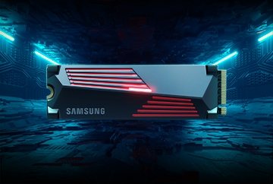

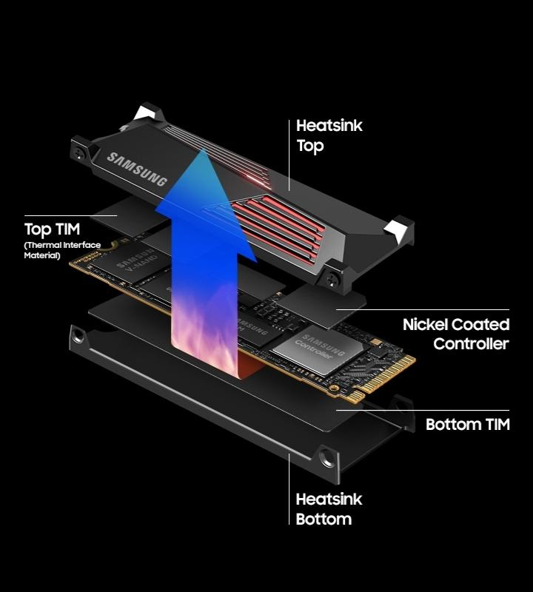

**Reach the next level**

**Gen4 M.2 Internal Solid State Drive with Heatsink**

Got a need for speed? Gen4 steps up to the arena with faster transfer speeds and high-performance bandwidth—all while keeping things cool. With a more than 55% improvement in random performance compared to 980 PRO, it’s fully here for faster loading.

**The fastest SSD from the world's #1 flash memory brand²**

**Read/Write Speeds up to 7,450/6,900 MB/s**

The speed you need for any occasion. And with read and write speeds up to 7450/6900 MB/s³ you’ll reach near max performance of PCIe®4.0⁴ powering through for any use. Our fastest data-transfer speeds dare to zoom past the finish line for the ultimate experience.

*²Source: 2003-2023 OMDIA data: NAND suppliers' revenue market share.  
³PCIe 4.0’s best theoretical sequential read is 8000 MB/s - 990 PRO reaches 7450 MB/s as of Q3, 2022.  
⁴Sequential and random write performance was measured with Intelligent Turbo Write technology being activated. Intelligent Turbo Write operates only within a specific data transfer size. Performance may vary depending on SSD’s firmware, system hardware & configuration and other factors. For detailed information, please contact your local service center. 990 PRO reaches 7,450 MB/s based on test system configuration: AMD Ryzen 7 5800X 8-Core Processor CPU@3.80GHz, DDR4 3600MHz 16GBx2 (PC4-25600 Overclock), OS - Windows 10 Pro 64bit, Chipset - ASRock-X570 Taichi. To maximize the performance of the 990 PRO, please check whether your system supports PCIe 4.0 at the Intel or AMD website.*

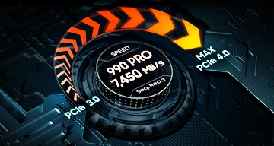

**Play without limits**

**Storage Capacities from 1TB to 2TB**

Give yourself some space with storage capacities up to 2TB. Sync all your biggest saves with the SSD that reigns supreme in any situation—whether you’re using it for gaming, video editing, data analysis or more.

**Made with PS5™ in mind**

**Integrated heatsink and PS5 Compatible**

Power through all your go-to games and avoid the sudden performance drops. The ultra-slim Integrated Heatsink was designed to dissipate heat from your device to stabilize its temperature and prevent performance issues. Compatible with your PlayStation® 5 for uninterrupted play.⁵

*⁵PCI-SIG®D8 standard spec: 8.8mm.*



**It's a power move**

**Power Efficiency**

Save the power for your performance. Get power efficiency all while experiencing up to 50% improved performance per watt over the 980 PRO.⁶ It makes every move more effective with less power consumption overall.

*⁶980 PRO Sequential Read/Write - 1,129/877 MB/Watt, 990 PRO Sequential Read/Write - 1380/1319 MB/Watt based on test result of 1TB capacity model.*